Project Design Phase-II Technology Stack (Architecture & Stack)

|  |  |
| --- | --- |
| Date | 17 October 2022 |
| Team ID | PNT2022TMID40676 |
| Project Name | Personal Expense Tracker Application |
| Maximum Marks | 4 Marks |

Technical Architecture:

The Deliverable shall include the architectural diagram as below and the information as per the table1 & table 2

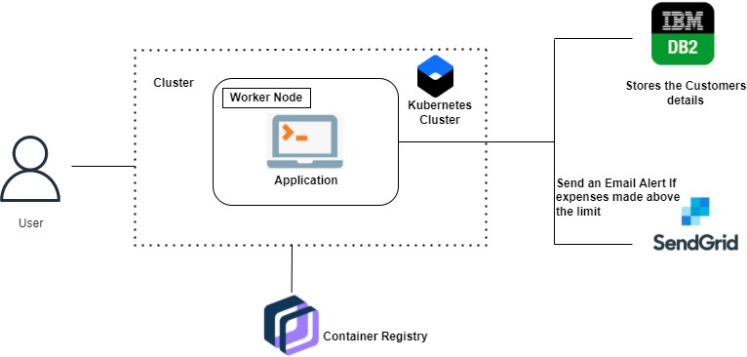

Table 1 : Components & Technologies:

|  |  |  |  |
| --- | --- | --- | --- |
| **S.No** | **Component** | **Description** | **Technology** |
| 1. | User Interface | The user can interact with the application with the use of a Chatbot. | HTML, CSS, JavaScript / Angular Js / React Js etc. |
| 2. | Application Logic-1 | The application contains the sign-  in/sign-up where the user will log in to the main dashboard. | Java / Python |
| 3. | Application Logic-2 | The dashboard contains the fields like Add income, Add Expenses, and Save Money. | IBM Watson STT service |
| 4. | Application Logic-3 | The user will get the expense report in graph form and also get alerts if the expense limit exceeds. | IBM Watson Assistant |
| 5. | Database | The Income and Expense data are stored in the MySQL database. | MySQL, NoSQL, etc. |

|  |  |  |  |
| --- | --- | --- | --- |
| 6. | Cloud Database | With the use of Database Service on the Cloud, the User data are  stored in a well-secured Manner. | IBM DB2, IBM Cloudant etc. |
| 7. | File Storage | IBM Block Storage is used to  store the Financial data of the user. | IBM Block Storage or  Other Storage Service or Local Filesystem |
| 8. | External API-1 | It exposes a business's internal  resources to outside users or applications. | IBM Weather API, etc. |

Table 2: Application Characteristics:

|  |  |  |  |
| --- | --- | --- | --- |
| **S.No** | **Characteristics** | **Description** | **Technology** |
| 1. | Open-Source Frameworks | Flask Framework in Python is used to implement this Application. | Python-Flask |
| 2. | Security Implementations | This Application Provides high security to the user’s Financial data. It can be done by using the Container Registry in the IBM cloud. | Container Registry, Kubernetes Cluster |
| 3. | Scalable Architecture | Expense Tracker is a lifetime access supplication. Its demand will increase when the user’s income is high. | Container Registry, Kubernetes Cluster |
| 4. | Availability | This application will be available to the user at any part of time. | container Registry, Kubernetes Cluster |
| 5. | Performance | The performance will be high because there will be no network traffics in the application. | Kubernetes Cluster |